Part 1.1 Network types.

Starting with LAN network (local area network) and this network type is used in a localized area, such as an office or a home. Matter fact, LAN network use wired connections to link the computers to each other and to variety of peripheral devices such as printers, and that is how they are able to access data from any machine that is connected to the network. In addition, LAN users can communicate with each other by chat or email. On the other hand, there is some advantages and disadvantages of the LAN network. The one advantages are that it is not outrageously costly and simple to configure, and the one disadvantage is that it is east to gain access to others software components and difficult to handle uneven loading.

The WAN network (wide area network), this network is used for companies and clients thus it effectively carry out its daily function regardless of location. Furthermore, it is used because it extends over a large area. Some advantages about the WAN network: easy of communication and share information over large area, some disadvantages are that it is WAN network is a big and complex problem and security problem.

WLAN network (wireless local area network), is used to link two or more devices with a wireless communication within a limited area such as a home, computer laboratories in school and buildings, and that gives us the ability to stay connected to the internet while moving. Some of the advantages about the WLAN network that it provides high rate to small area coverage, and some disadvantages are that it is limited area to hide and if there is any bad weather like rain or thunder the communication may interfere.

If we want to mention a network that can be used for devices to communicate with each other’s application without a host, it is the CAN network (controller area network), which can be used in electric power steering, audio video systems and sports cameras. The advantages of CAN network is that it coast low and lightweight network and it has a standard bus in distributed network, the disadvantages are that it has high software expenditure and undesirable interaction more probable.

PAN network (personal area network), it is used for a limited area like when the connection is between a Bluetooth and a smartphone. In addition, the ranges from a few centimeters to a few meters like connecting laptops, printers, keyboard and other devices. The advantages of the PAN network are that it is efficient, cost effective, and convenient. Moreover, the disadvantages is that Bluetooth networks are relatively secure and have a slow data rates.

Network topology

Star topology:

In the star topology, each host is connected to a central hub or switch with a point-to-point connection, which makes it higher coast because of the cabling. In addition, two or more computers may send messages at the same time. On the other hand, if signals transitions down, the entire network down.

Mesh topology:

The mesh topology provides the best in networking speeds in addition to frequency and coverage for a specific area and can handle much more modes and devices at once. In this case, if the network is down, only the connected devices are down. This topology can allow much more data transition than another and allows for automatic connection to the best access point.

Bus topology:

In the bus topology, we have the simplest layout, in which it is connected to a single cable called trunk/backbone that looks like the letter T, and because of that, it cost low to implement. In addition, only one computer can send messages at a time and each computer receives the message, but ignores if it not addressed to it and this topology Is called passive topology that computers only listen for, not regenerate data.

Ring topology:

A ring topology is the same as the Bus topology but in a closed loop, it uses peer to peer network in which its data travels around the ring in one direction. Matter fact, these is an intermediate nodes repeat that the data keep the signal strong. On the other hand, there is one disadvantage which is the network bandwidth is bottlenecked by the weakest link between two nodes.

Tree topology:

The tree topology is a mix between the star and bus topology, and that’s because it is connected to a bus network and in a physical star topology, in which it is a hybrid network topology so the tree networks are hierarchical, and each node can have an arbitrary number of child nodes.

Part 1.4, 1.5, 1.6, and 1.7 Networking protocol & Networking devises

***DHCP:***

*The DHCP will help in providing IP addresses and arrangement to the PC’s connected to the network, and will use different subnets and classes to arrange devices and branches.*

***Gigabit Ethernet:***

*This is used to connect between networking devices that include the switch and router, or in other words the main devices.*

***Fast Ethernet:***

*This is the main cable that connects between the switch and PC’s, in addition to the printers and access points.*

***FTP:***

*This is known as File transfer protocol, which will be used to transfer files from or to a network share and/or cloud storage, in addition to being used for email file transfers.*

***DNS:***

*This is known as domain name server, which is used to provide the connection to the main internet, and will providing info for any actions performed on the network.*

***Email:***

*Two protocols will be used for email. POP3 and SMTP, Pop is used for sending emails out of your mailbox, whereas SMTP is used for receiving emails. They gather as a send and receive for emails.*

***HTTPS:***

*This is essential to provide a secure connection to websites that are visited, as some websites don’t support standard HTTP. This is commonly used on secure websites that have payment and banking involved.*

***Router***

*The main router is used to connect up to the modem in addition to all the devices on the network and will be the management console for all Clients. All will be connected including switches, etc.*

***Switch***

*The switch is used as a hub that expands the usability of one port on the router and provides expansion to connect much more devices, up to 100 port switch. It comes in 100 and 1000 models.*

***Printer***

*This is used to print your work out and considered as a needed tool for any office. Some of them have a scanner in addition to a copier which can be handy in some cases.*

***Access point***

*An access point provides wireless connection to devices that are around. Smartphones, laptops, and more as well as strengthening the connection in the area. A specific name is set for each access point as well as a unique password.*

***PC:***

*The PC is used to develop games and perform daily tasks that are required in any company. Some tasks include web browsing, emails and more.*

*Part 1.6 & part 1.7*

***Server:***

*The main server holds 5 virtual machines, each responsible for a role. DNS, DHCP, SMTP and more. Each one of them is responsible for a specific task and distributing to the users on the network.*

***Server types:***

*There are two types of servers, windows server and linux server. The best option would be to use windows server OS.*

***Windows server:***

*Windows server 2022 is the most recent server version from Microsoft. There are different editions of windows server which include standard and datacenter. I will be using datacenter as a more feature rich version than standard and has more capability and expansion room when it comes to roles and features. There are different editions of windows server which include core and GUI. Core is a command line based interface, whereas the GUI version includes a general graphical user interface with more capabilities than the command line version. It allows for better management and is more secure.*

Part 2.

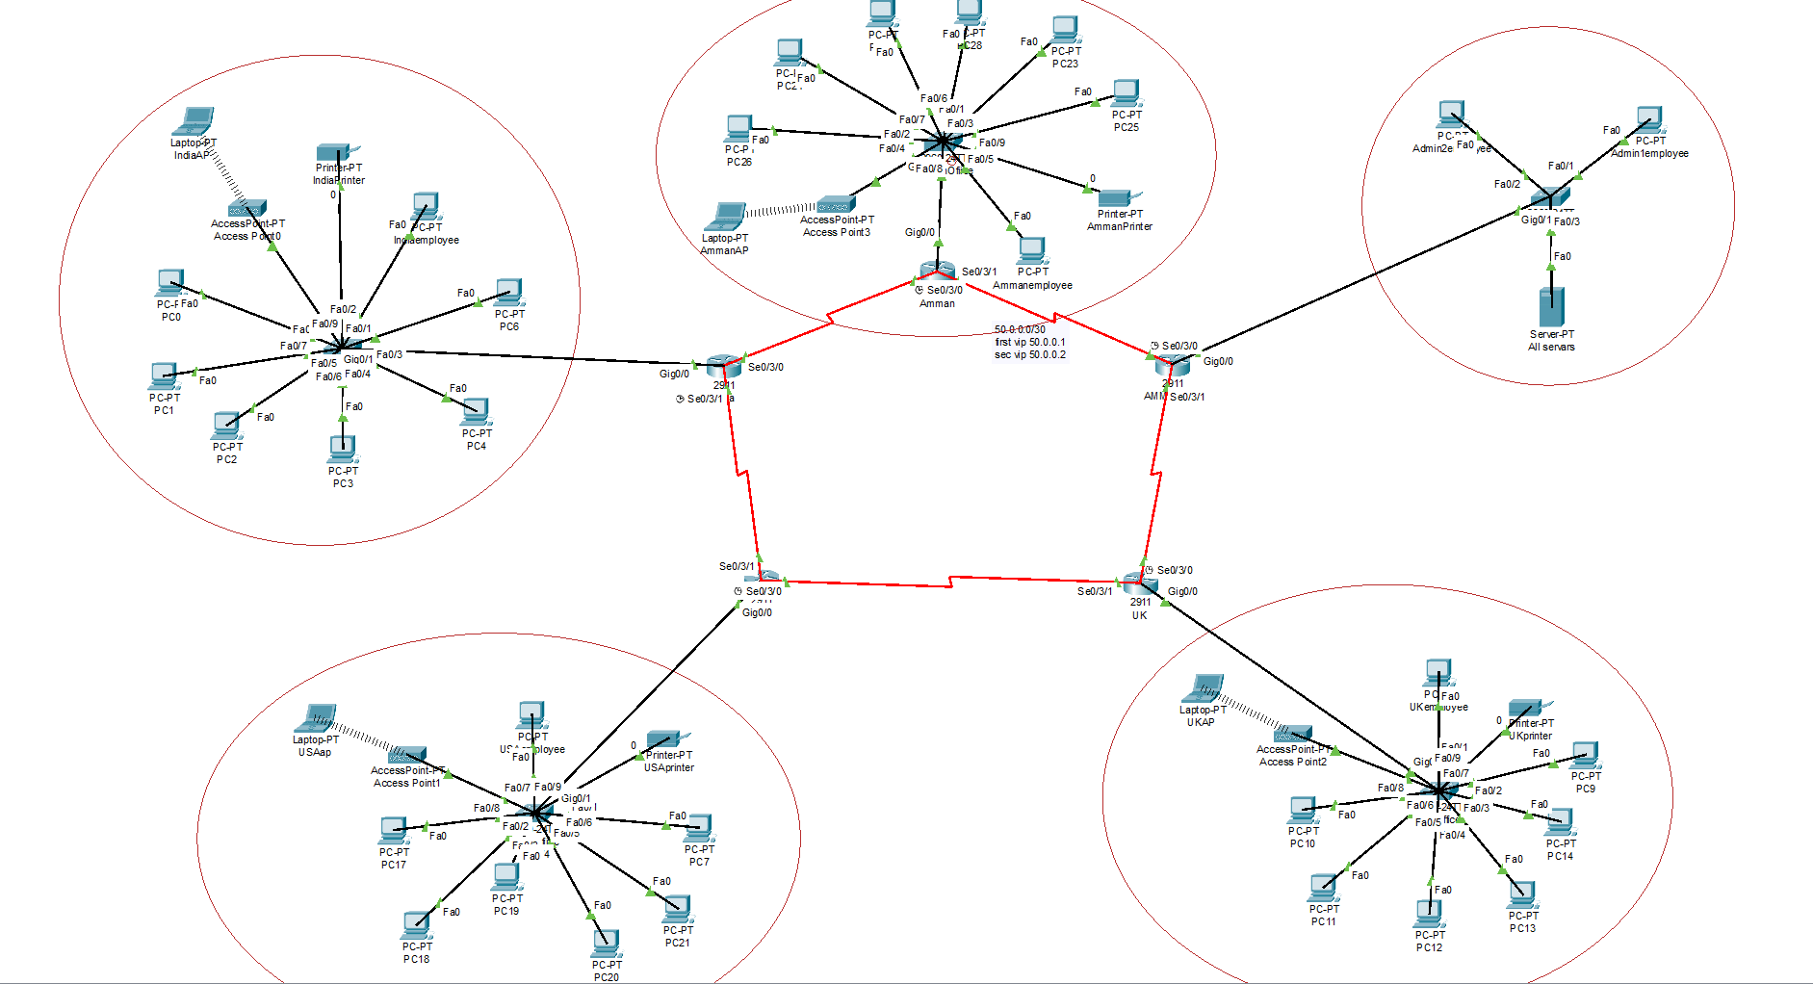

This network shows LANs for each office in each country as well as the access point devices that allows portable devices outside the LAN to connect to the network wirelessly. Each LAN is connected to a router which each one of them is connected to one another and IP addresses are given as required. Moreover, they are connected using the OSPF routing protocol, as it counts as one of the most efficient routing protocols. As for the default route, loopback is used. While the headquarter in Amman consists of 2 administrators and a server which all the services needed is switched on.

IP configurations

The following IP configuration is for India subnet

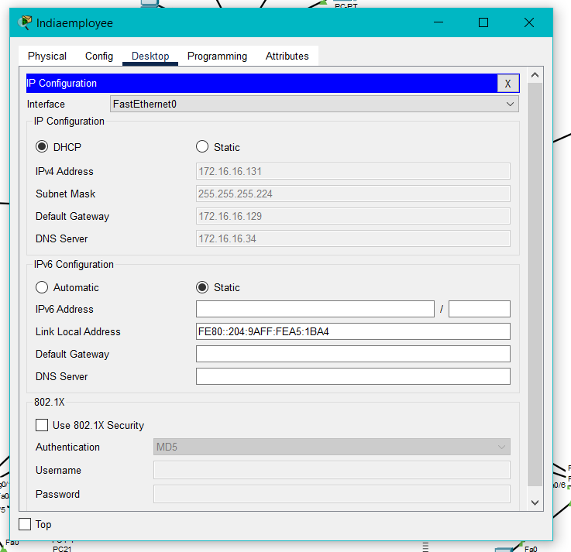

The following IP configuration is for Amman subnet

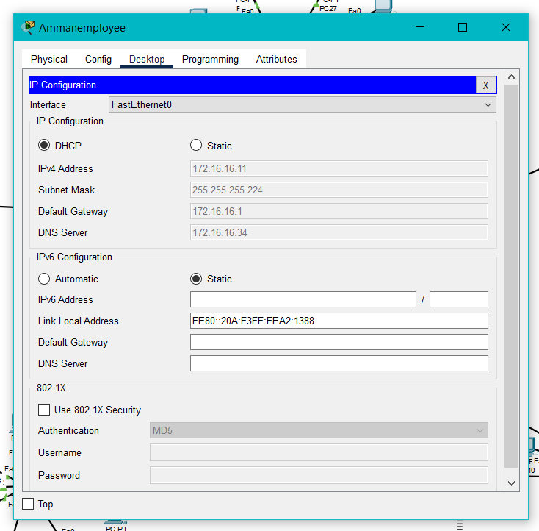

The following IP configuration is the first admin for HQ Amman

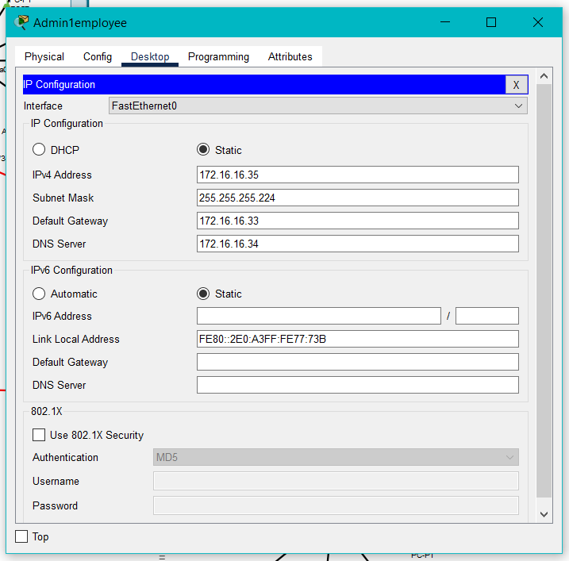

The following IP configuration is the second admin for HQ Amman

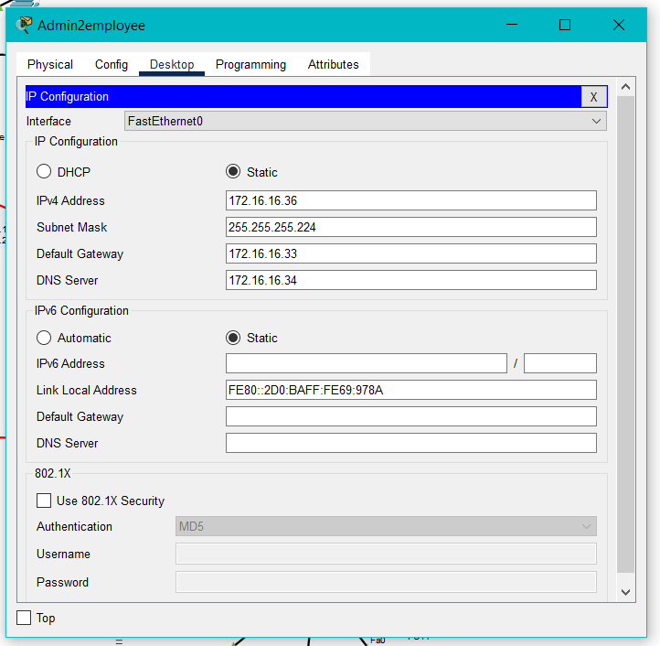

The following IP configration is for UK subnet

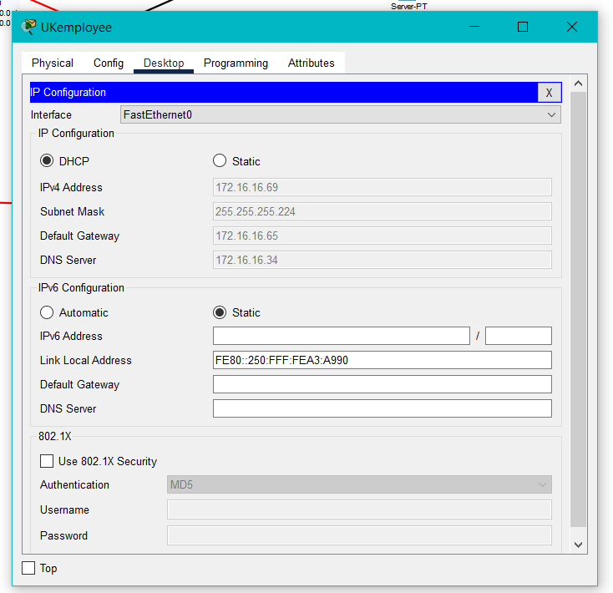

The following IP configuration is for USA subnet

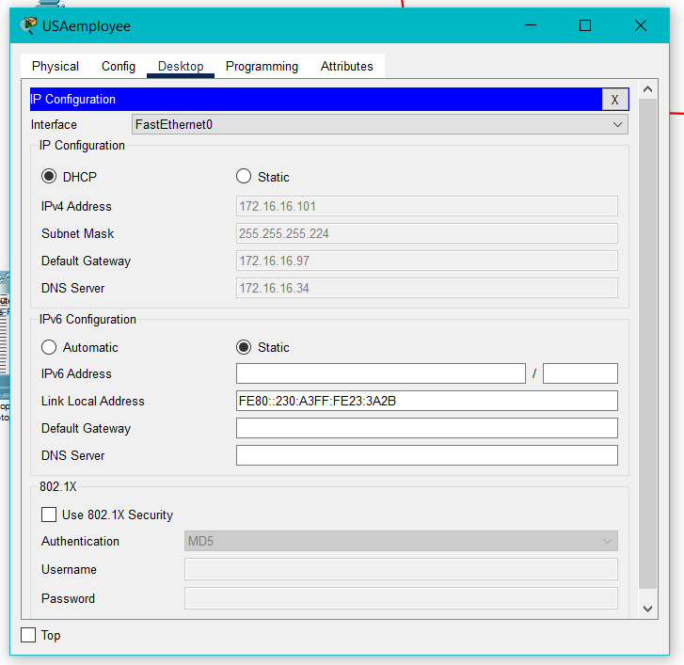

Subnets for LAN (local area network)

|  |
| --- |
| 172.16.16.0/24  1111 1111.1111 1111.1111 1111.0000 0000  8N.8N.8N.8H  .0000 0000  .1111 1111  2^x=h -> 2^x=22 -> 2^5=32  Each LAN must consist of 22 host |
| 8N.8N.8N.5H and 3S  Block size= 2^h  2^5=32  Block size-2 =30 valid IP addresses per subnet  172.16.16.0  172.16.16.32 |
| Subnet 1 = 172.16.16.0/27  1st valid = 172.16.16.1  2nd valid = 172.16.16.2  Last valid = 172.16.16.30  Broadcast = 172.16.16.31  Subnet 2 = 172.16.16.32/27 |
| Subnet 2 = 172.16.16.32/27  1st valid = 172.16.16.33  2nd valid = 172.16.16.34  Last valid =172.16.16.62  Broadcast = 172.16.16.63  Subnet 3 = 172.16.16.64/27 |
| Subnet 4 = 172.16.16.96/27  1st valid = 172.16.16.97  2nd valid = 172.16.16.98  Last valid =172.16.16.126  Broadcast =172.16.16.127  Subnet 5 = 172.16.16.128/27 |
| Subnet 5 = 172.16.16.128  1st valid = 172.16.16.129  2nd valid = 172.16.16.130  Last valid = 172.16.16.158  Broadcast = 172.16.16.159 |

The previous subnetting is for the LAN’s in each office. However, I did these subnets based on the main IP address that was given by the company.

Subnets for WAN (wide area network)

|  |
| --- |
| 50.0.0.0/30  Block size=2^2=4 |
| Subnet 1= 50.0.0.0  1st valid = 50.0.0.1  2nd valid = 50.0.0.2  Broadcast = 3  Subnet 2= 50.0.0.4 |
| Subnet 2 = 50.0.0.4  1st valid = 50.0.0.5  2nd valid = 50.0.0.6  Broadcast = 50.0.0.7  Subnet 3 = 50.0.0.8 |
| Subnet 3 = 50.0.0.8  1st valid = 50.0.0.9  2nd valid = 50.0.0.10  Broadcast = 50.0.0.15  Subnet 4 = 50.0.0.16 |
| Subnet 4 = 50.0.0.16  1st valid = 50.0.0.17  2nd valid = 50.0.0.18  Broadcast = 50.0.0.19  Subnet 5 = 50.0.0.20 |

Test Plan:

|  |  |  |
| --- | --- | --- |
| Command name | What to be tested | Expected results |
| ftp | The ability of sharing files between devices through the ftp server | The files sent were found in the directory of the received device |
| Ping | Checking the connectivity between devices | No loss in the packets sent and received |
| Nslookup | Examining the DNS in the network | The correct domain name and the IP address were listed |
| Tracert | Tracing the routes between devices | The routes were listed including the maximum hop count |
|  |  |  |

The following picture is the IP route for Amman router (directly and remotly)

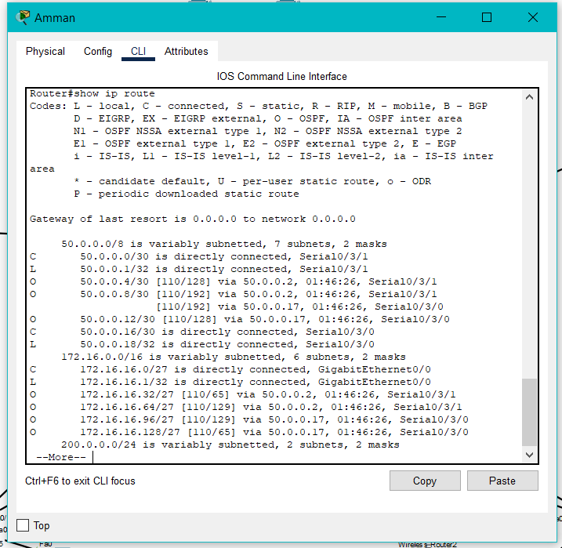

The following picture is the IP route for HQ Amman router (remotly and directly )

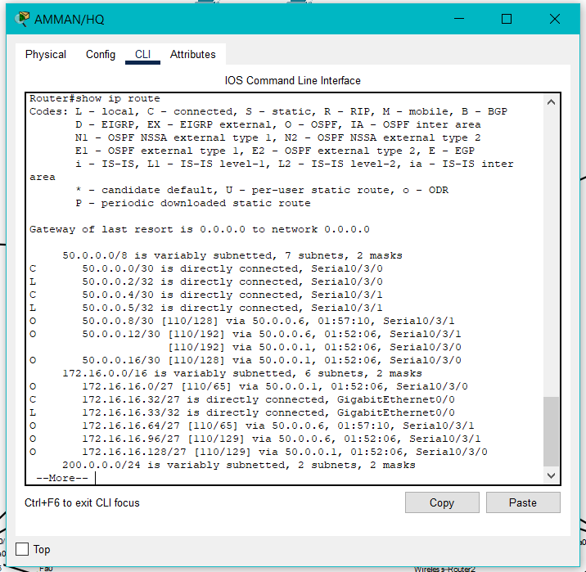

The following picture is the IP route for UK router (remotly and directly )

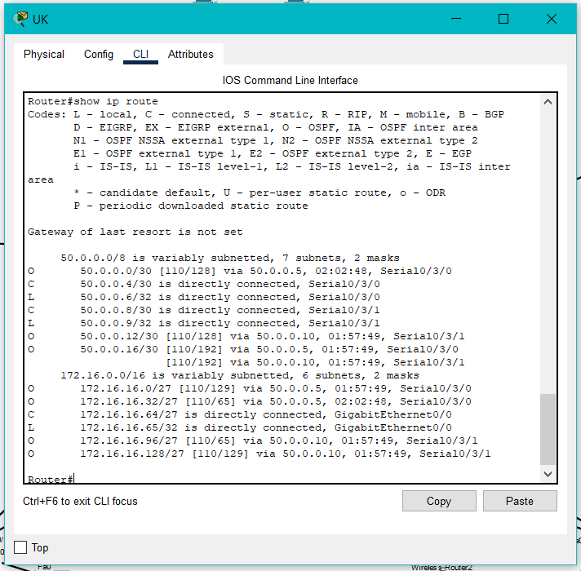

The following picture is the IP route for USA router (remotly and directly )

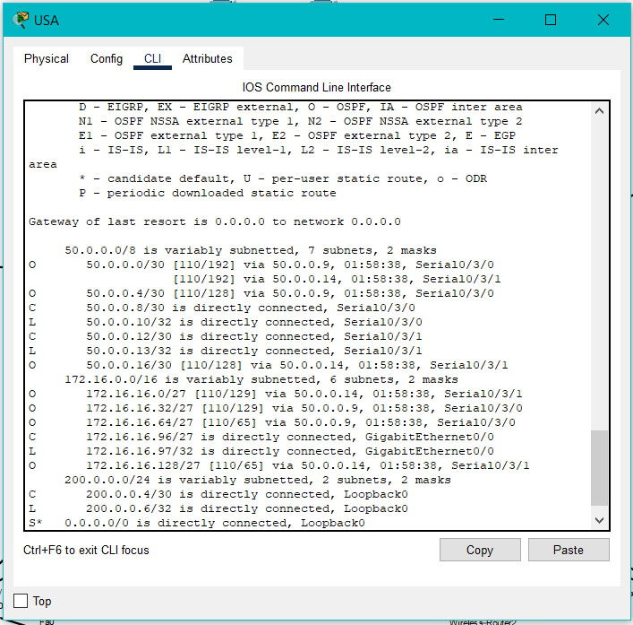

The following picture is the IP route for India router (remotly and directly )

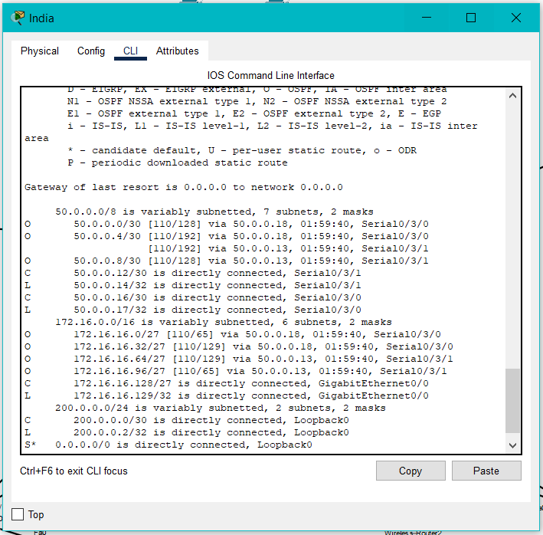

Testing Web service, using Web Browser

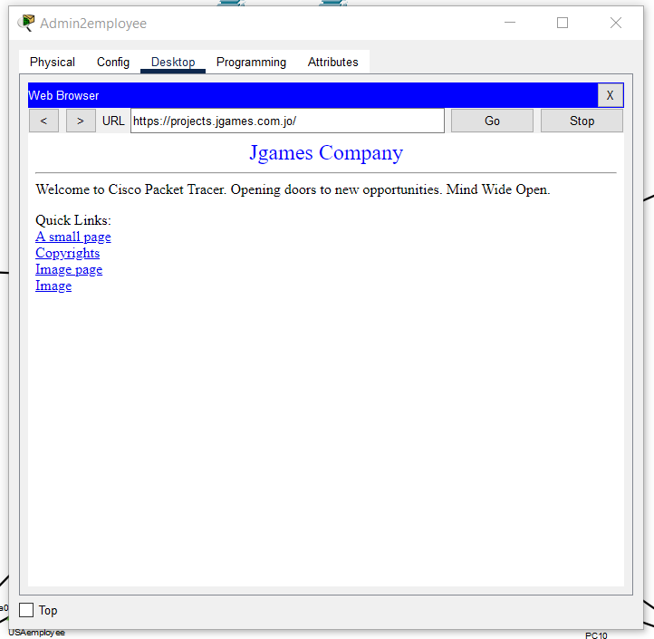

Testing and sending email from Amman employee to UKemployee.

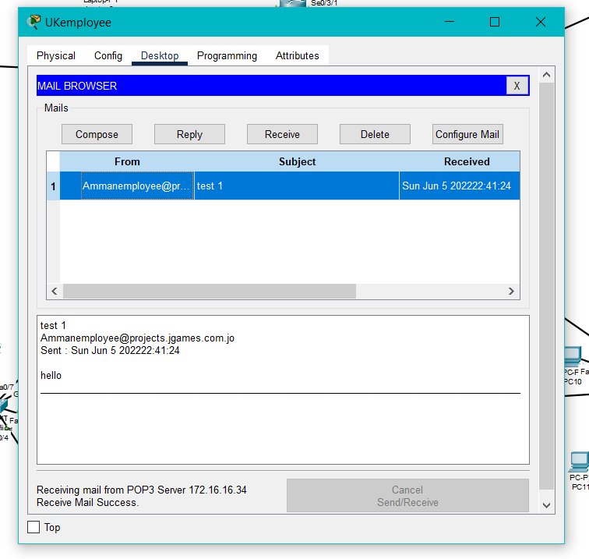

The NSLOOKUP testing command

Using the command from USAemployee to admin1

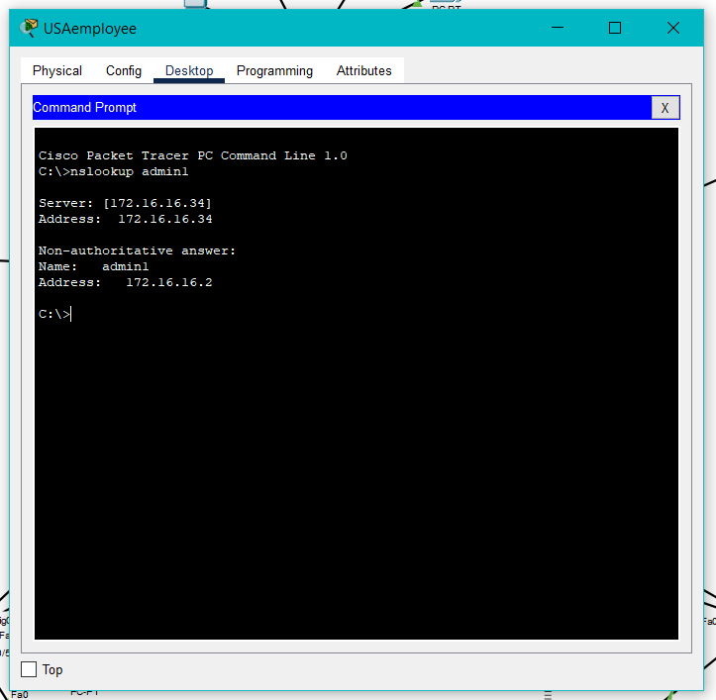

Using the command from Indiaemployee to admin2:

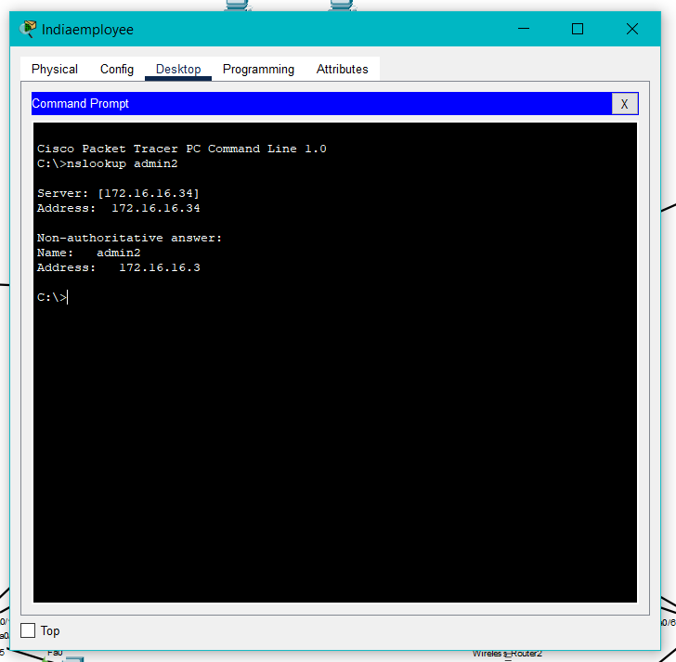

Testing FTP (file transportation protocol)

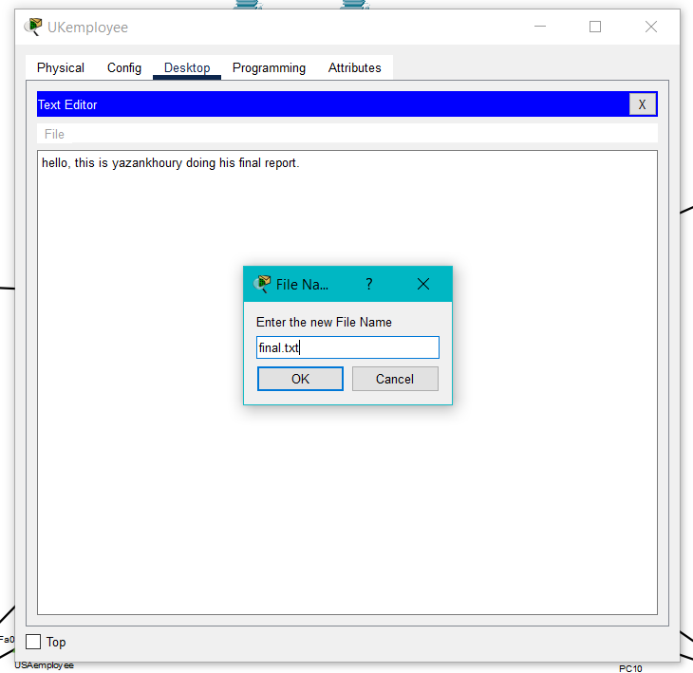

Using FTPto transport files from UKemployee to USAemployee

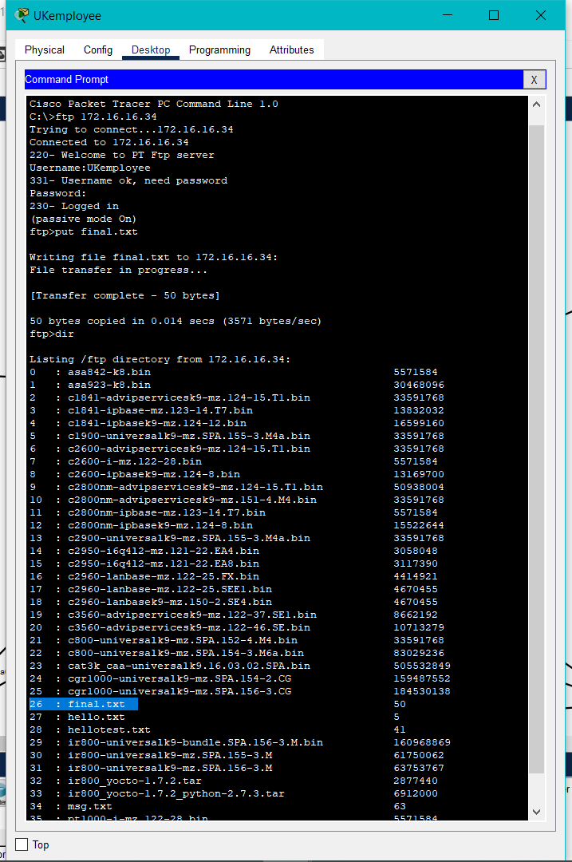

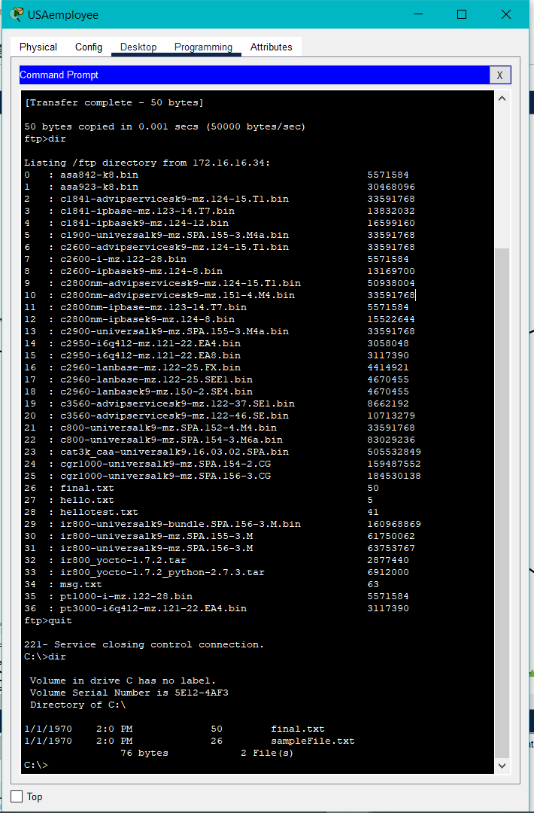

Sending pings from Admin1employee to Indiaemployee

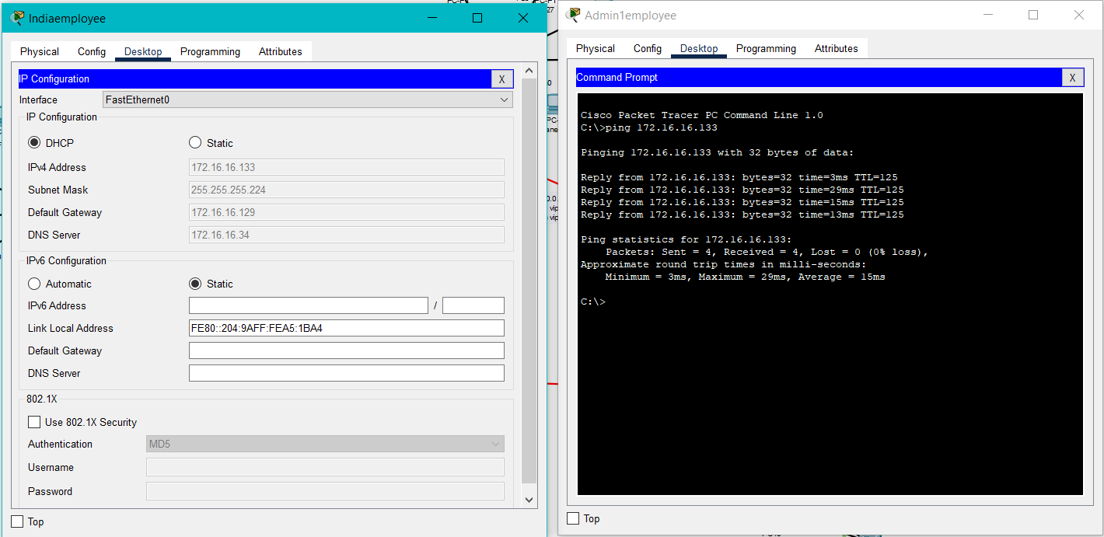

Sending pings from Ammanemployee to USAemployee

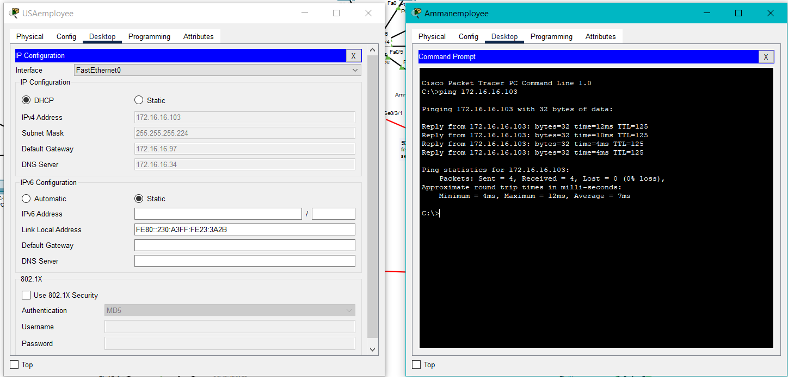

Tracing routes from UKemployee to Indiaemployee

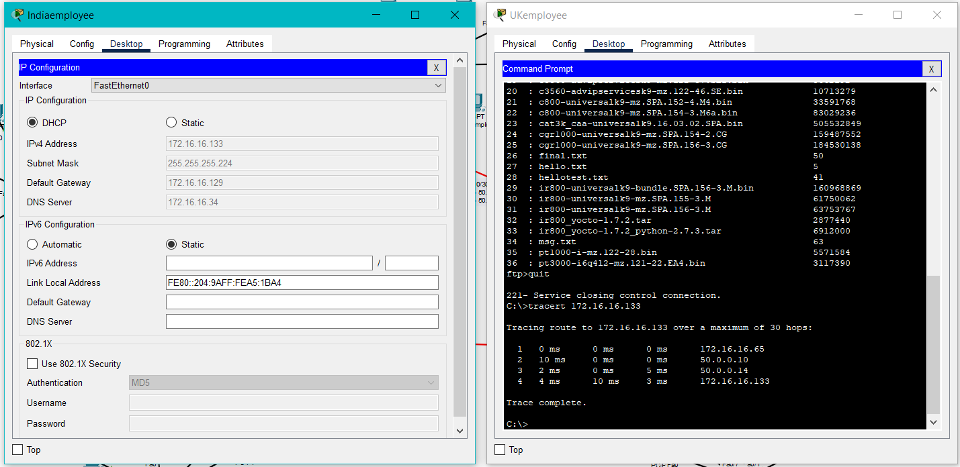

Test results against the expected results

|  |  |  |
| --- | --- | --- |
| Command name | Expected results | Testing results |
| ftp | The files sent were found in the directory of the received device | Similar to the expected results |
| ping | No loss in the packets sent and received | Four packets were sent but three packets were received at the first try |
| nslookup | The correct domain name and the IP address were listed | Similar to the expected results |
| tracert | The routes were listed including the maximum hop count | Similar to the expected results |

Maintenance schedule

|  |  |  |  |  |  |  |
| --- | --- | --- | --- | --- | --- | --- |
| S# | Support given for the network | Day 1 | Day 3 | Day 5 | Day 7 | Day 9 |
| 1 | Using the command ping between different devices | ✔ |  |  | ✔ |  |
| 2 | Checking the network design |  | ✔ |  |  |  |
| 3 | Examine the routes |  |  | ✔ |  |  |
| 4 | Testing commands for services |  |  |  |  | ✔ |
| 5 | Checking the IP addresses in each device’s configuration information |  |  |  | ✔ |  |

Recommendation and critical evaluation

The best recommendation to improve this network design in the future would be adding more access points to get more network coverage in different areas and get a better signal strength in more rooms. In addition to adding, more Ethernet jacks in the location to have, a larger number of Ethernet plugs for future improvement, in addition to upgrading the routers and switches to the newer models that come out in the future.

My work is well organized and it has a specific details to every step taken, and it is understandable and clear for anyone who would look through. Moreover, it refers to everything the company asked for to do in this project and all the information needed is listed in more than a one format. Matter fact, I believe that this design is one of the best designs that J-games Company would ever ask for.